Class 12th
UNIT 1: PYTHON PROGRAMMING-II
A. Objective Type Questions
1. Which of the following is a primary data structure in Pandas?
a) List
b) Tuple
c) Series
d) Matrix
Answer: c) Series
Explanation: A Series is the primary one-dimensional data structure in the Pandas library. It stores data in a single column with an associated index.

2. What does the fillna(0) function do in Pandas?
a) Removes rows with missing values
b) Fills missing values with zeros
c) Estimates missing values based on averages
d) Converts all data to zero
Answer: b) Fills missing values with zeros
Explanation: The fillna() method replaces missing (NaN) values with the value provided. When 0 is passed, all missing values become 0.

3. In Linear Regression, which library is typically used for importing and managing data?
a) NumPy
b) Pandas
c) Matplotlib
d) Scikit-learn
Answer: b) Pandas
Explanation: Pandas is mainly used to load, organize, clean, and manage datasets before applying a machine learning algorithm like Linear Regression.

4. What is the correct syntax to read a CSV file into a Pandas DataFrame?
a) pd.DataFrame("filename.csv")
b) pd.read_csv("filename.csv")
c) pandas.read_file("filename.csv")
d) pd.file_read("filename.csv")
Answer: b) pd.read_csv("filename.csv")
Explanation: The read_csv() function reads data from a CSV file and stores it in a Pandas DataFrame.

5. What is the result of the df.shape function?
a) Data type of the DataFrame
b) Number of rows and columns in the DataFrame
c) Memory usage of the DataFrame
d) Column names of the DataFrame
Answer: b) Number of rows and columns in the DataFrame
Explanation: The shape attribute returns a tuple in the form:(rows, columns)

6. Which function can be used to export a DataFrame to a CSV file?
a) export_csv()
b) to_file()
c) to_csv()
d) save_csv()
Answer: c) to_csv()
Explanation: The to_csv() method saves a Pandas DataFrame as a CSV file.
____________________________________
B. Short Answer Questions

Q1. What is a DataFrame in Pandas?
Answer:-A DataFrame is a two-dimensional, tabular data structure provided by the Pandas library. It consists of rows and columns with labeled axes and can store data of different types, such as integers, strings, and floating-point numbers. It is widely used for storing, organizing, and analyzing structured data.

Q2. How do you create a Pandas Series from a dictionary?
Answer:-A Pandas Series can be created from a dictionary by passing the dictionary to the pd.Series() function. The dictionary keys become the index, and the corresponding values become the elements of the Series.
Example:
import pandas as pd
data = {'A': 10, 'B': 20, 'C': 30}
s = pd.Series(data)
Q3. Name two strategies to handle missing values in a DataFrame.
Answer:-Two common strategies for handling missing values in a DataFrame are:
1. Removing missing values using the dropna() function.
2. Replacing missing values using the fillna() function with a suitable value such as 0, the mean, or the median.

Q4. What does the head(n) function do in a DataFrame?
Answer:-The head(n) function is used to display the first n rows of a DataFrame. It helps in quickly viewing and inspecting the data. If n is not specified, it displays the first five rows by default.
Example:
df.head(3)

Q5. What is the role of NumPy in Python programming?
Answer:-NumPy (Numerical Python) is a Python library used for performing numerical and mathematical operations efficiently. It provides support for multidimensional arrays, matrices, and a wide range of mathematical functions, making data processing faster and more efficient.

Q6. Explain the use of the isnull() function in Pandas.
Answer:-The isnull() function is used to identify missing or null values in a DataFrame or Series. It returns True for missing values and False for non-missing values. It is commonly used to detect missing data before performing data cleaning.
Example:
df.isnull()
____________________________________
C. Long Answer Questions
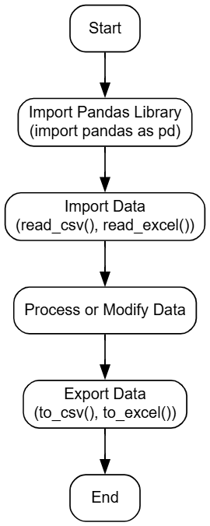
Q.1 Describe the steps to import and export data using Pandas.
Answer:- Introduction:-Pandas is an open-source Python library used for data manipulation and analysis. It provides simple functions to import data from different file formats, process the data, and export the modified data into a new file.
1. Import the Pandas Library
The first step is to import the Pandas library using the statement import pandas as pd. This makes all the Pandas functions available for reading, processing, and exporting data.
2. Import the Data
Use functions such as pd.read_csv() or pd.read_excel() to import data from a file. The imported data is stored in a DataFrame, which is easy to view and manipulate.
3. Process or Modify the Data
The DataFrame can be filtered, sorted, updated, or analyzed. Pandas provides many built-in functions to clean and organize the data efficiently.
4. Export the Data
save the DataFrame using functions such as to_csv() or to_excel(). This creates a new file containing the updated data.
5. Verify the Exported File
check that the exported file is created successfully and contains the correct data. This ensures that all modifications have been saved properly.
Conclusion:-Pandas provides a simple and efficient way to import, process, and export data. Its built-in functions make data handling faster, easier, and more reliable for data analysis tasks.

Q.2. Explain the concept of handling missing values in a DataFrame with examples.
Answer:-Introduction :-A missing value is a value that is not available in a DataFrame. In Pandas, missing values are shown as NaN (Not a Number). It is important to handle missing values before analysing the data because they can affect the result.
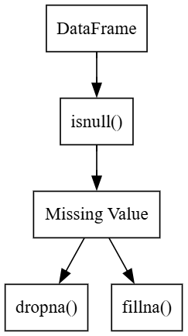
Diagram/flowchart:-
1. Check Missing Values
Use the isnull() function to check whether a DataFrame has missing values. It returns True for missing values and False for available values.
2. Remove Missing Values
The dropna() function removes the rows that contain missing values. This method is useful when only a few rows have missing data.
3. Replace Missing Values
The fillna() function replaces missing values with another value such as 0 or 1. It helps to keep all the rows in the DataFrame.
4. Handling missing values improves the quality of the data. It helps to get correct results during data analysis and machine learning.
Example:-
import pandas as pd
df = pd.DataFrame({"Marks":[90,None,80]})
print(df.fillna(0))
Conclusion:- Handling missing values is an important step in data analysis. Pandas provides simple functions like isnull(), dropna(), and fillna() to make the data complete and useful.

Q.3 Compare NumPy arrays and Pandas DataFrames.
Answer:-
NumPy Array | Pandas DataFrame
Stores data in the form of an array. | Stores data in the form of rows and columns.
Stores only the same type of data. | Can store different types of data in different columns.
Does not have row and column names. | Has row index and column names.
Used for numerical calculations. | Used for storing, analysing, and managing tabular data.
Faster for mathematical operations. | Better for data analysis and data processing.
Supports one-dimensional and multi-dimensional arrays. | Supports only two-dimensional tabular data.
Created using the NumPy library. | Created using the Pandas library.
Common functions are array(), reshape(), and zeros(). | Common functions are DataFrame(), head(), and tail().

Q.5. How can we add new rows and columns to an existing DataFrame? Explain with code examples
Answer:-Introduction:- A DataFrame can be updated by adding new rows and columns. Pandas provides simple methods to insert new data without creating a new DataFrame.
1. Adding a New Column
A new column is added by using the column name inside square brackets. The values of the new column are assigned as a list.
Example 1: Add a New Column
import pandas as pd
df = pd.DataFrame({"Name":["A","B"]})
df["Marks"] = [90,80]
print(df)
2. Adding a New Row
A new row is added by using the loc[] method. The row label and values are given to insert the new row.
Example 2: Add a New Row
df.loc[2] = ["C",85]
print(df)
3. Existing Data Remains Safe
Adding a new row or column does not remove the existing data. It only updates the DataFrame with new values.
4. Easy Data Management
Adding rows and columns helps to update records, store new information, and manage data easily.
Conclusion:-Pandas makes it easy to add new rows and columns to a DataFrame. The [] operator is used to add a column, and the loc[] method is used to add a row.

Q.6. What are the attributes of a DataFrame? Provide examples.
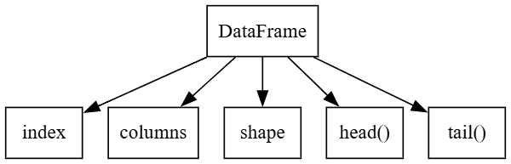
Answer:-Introduction:-A DataFrame has different attributes that provide information about its rows, columns, and size. These attributes help us understand the structure of the DataFrame.
1. index:-The index attribute returns the row labels of the DataFrame. It helps to identify each row.
Example:-
print(df.index)
2. columns:-The columns attribute returns the names of all columns in the DataFrame.
Example:-
print(df.columns)
3. shape:-The shape attribute returns the number of rows and columns as a tuple (rows, columns).
Example:-
print(df.shape)
4. head(n):-The head(n) function displays the first n rows of the DataFrame. If n is not given, it shows the first five rows.
Example:-
print(df.head(2))
5. tail(n):-The tail(n) function displays the last n rows of the DataFrame. If n is not given, it shows the last five rows.
Example:-
print(df.tail(2))
Conclusion:-DataFrame attributes help us know the structure and contents of the data. They make it easy to view and understand a DataFrame.

